PREREQUISITE

TEAM ID: PNT2022TMID19635

TEAM LEADER: SRIJA R

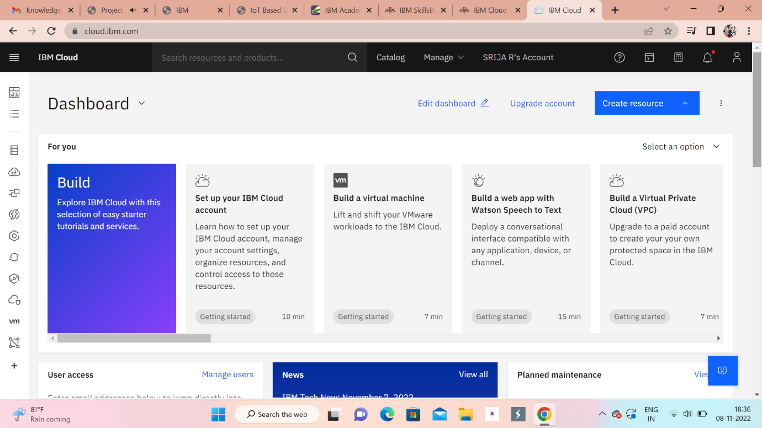

TEAM MEMBER: PATHMAVASAN R

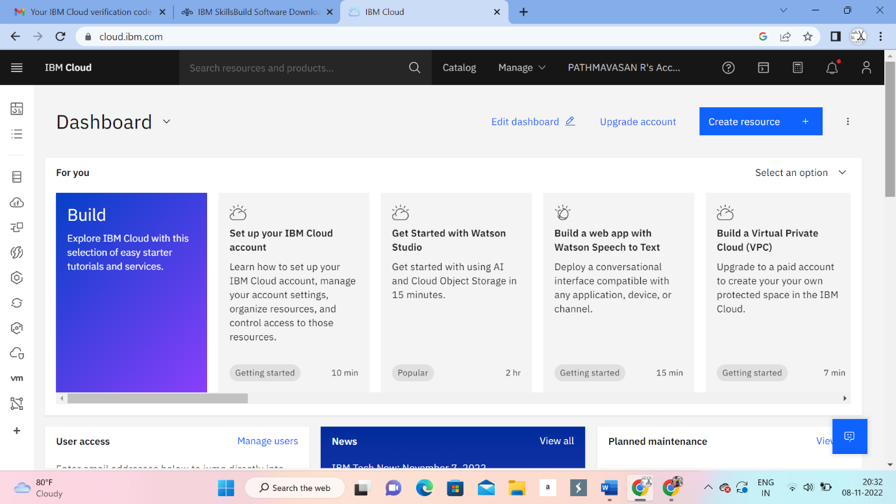

TEAM MEMBER: PRADEEP T R

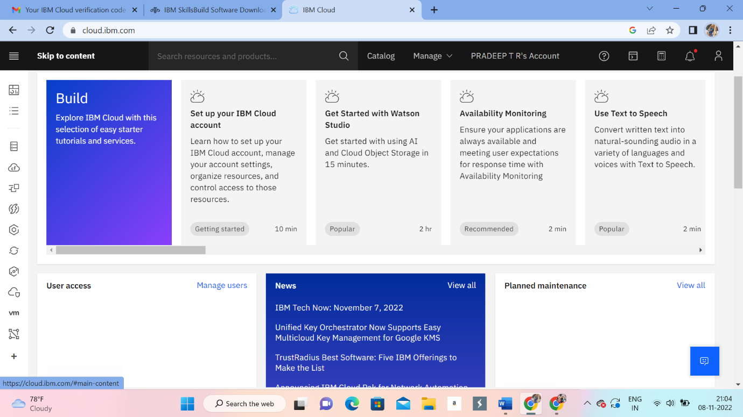

TEAM MEMBER: PRAVEEN N

